Dear Poojita,

Thanks for your assistance in our research. We are writing on a new data collection that we need your help with. Attached, you will find an excel file with URLs to the enforcement reports of the Food and Drug Administration (FDA). Each enforcement report contains information on product recalls. We would like you to extract the identities of the recalling firms and the manufacturers of the defective products in the reports published **from 2004 to June 2012**.

The following screenshot is an example of a recall. The highlighted part is what we want to collect.

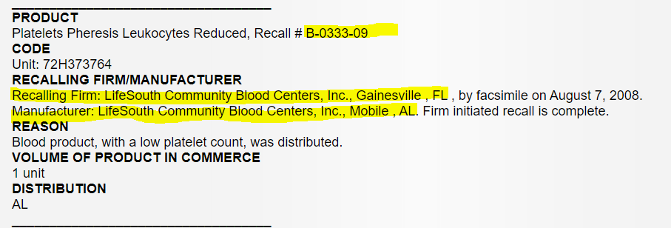

We would like to convert the information into the following data structure.

|  |  |  |  |  |
| --- | --- | --- | --- | --- |
| Recall ID | Recalling Firm | Recalling Firm Location | Manufacturer | Manufacturer Location |
| B-0333-09 | LifeSouth Community Blood Centers, Inc | Gainesville, FL | LifeSouth Community Blood Centers, Inc | Mobile, AL |

Some product recall does not contain information about the recalling firm. In these cases, please only fill in the information for the recalling firm. See below as an example.

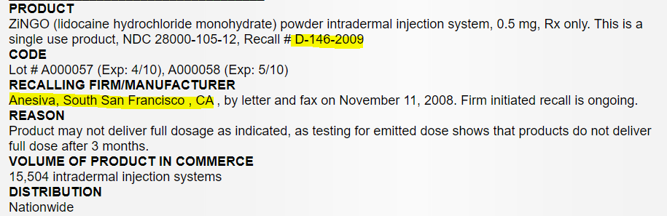

The extracted information will be as follows:

|  |  |  |  |  |
| --- | --- | --- | --- | --- |
| Recall ID | Recalling Firm | Recalling Firm Location | Manufacturer | Manufacturer Location |
| D-146-2009 | Anesiva | South San Francisco, CA |  |  |

Some penforcement reports include multiple Recall IDs.

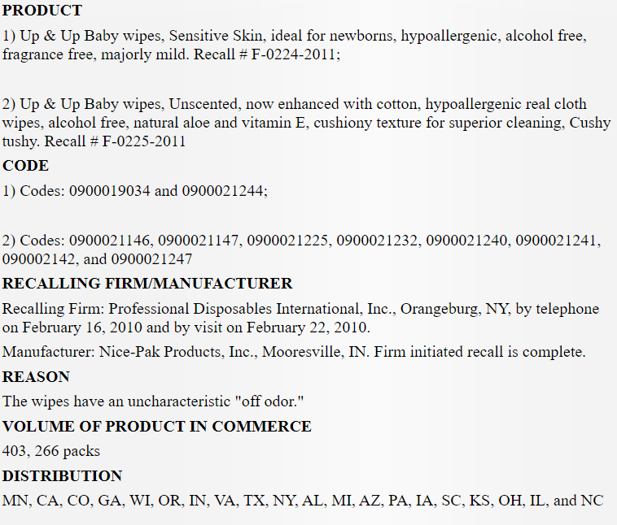

Please organize the extracted information as follows (please see next page). The recalling firm and manufacturer information will be the same for for all recalls in the same enforcement report section.

|  |  |  |  |  |
| --- | --- | --- | --- | --- |
| Recall ID | Recalling Firm | Recalling Firm Location | Manufacturer | Manufacturer Location |
| F-0224-2011 | Professional Disposables International, Inc. | Orangeburg, NY | Nice-Pak Products, Inc. | Mooresville, IN |
| F-0225-2011 | Professional Disposables International, Inc. | Orangeburg, NY | Nice-Pak Products, Inc. | Mooresville, IN |

Please let us know if you have any questions. Thanks!